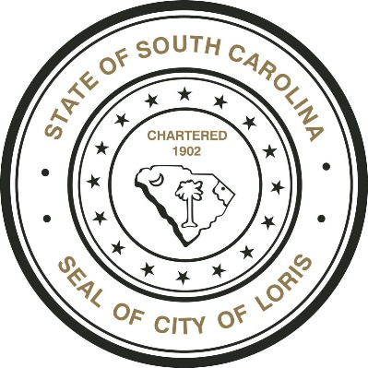

CITY OF LORIS

INVITATION TO BID

THE CITY OF LORIS, SC is accepting sealed bids for Solid Waste Collection & Disposal Services.

A Bid Conference will be held on Wednesday, April 11th, 2018 at 1:00 P.M. at the Loris Public Safety Building located at 3909 Walnut Street.

Bid acceptance date has been extended until 5:00 P. M., on April 25th, 2018.

Submit bid proposal to:
City of Loris. 4101 Walnut Street or P.O. Box 548, Loris, SC 29569-0548.

Mark envelope, “Solid Waste Collection & Disposal Services.”

To obtain a bid information package contact City Hall at (843)756-4004, in person at 4101 Walnut Street, Loris, SC 29569 or visit www.cityoflorissc.com.

The City reserves the right to accept or reject any and all bids and to waive informalities.

City of Loris

