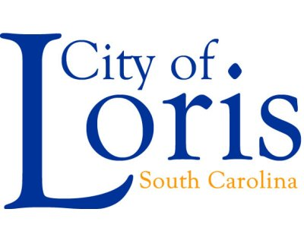 | 2023 – 2024  Standing Committees of Council
Public Safety  Lewis C. Hardee, Jr. – Chairperson  Carroll D. Padgett, Jr.  Kelli Gerald |  |  |  | Personnel & Finance  Andrea Coleman- Chairperson  Carroll D. Padgett, Jr.  Kelli Gerald
Buildings & Grounds  Joan Gause- Chairperson  Andrea Coleman  Tonya Sykes |  |  |  | Recreation  Kelli Gerald- Chairperson  Lewis C. Hardee, Jr.  Tonya Sykes
Planning, Annexation  Carroll D. Padgett, Jr.- Chairperson  Andrea Coleman  Joan Gause |  |  |  | Public Works  Tonya Sykes- Chairperson  Lewis C. Hardee, Jr.  Joan Gause

